MILLAND PARISH COUNCIL
---------------------------------------------------------------------------------------------------------------------------
Chairman: Mrs Louise Myles
Clerk: Miss Viki Williams
21 Pease Croft, South Harting, West Sussex, GU31 5LB
Tel: 07792 498087
Email: clerk@milland-wsx-pc.gov.uk –
Website: www.milland-wsx-pc.org.uk

MINUTES of the Meeting of MILLAND PARISH COUNCIL held on
Wednesday, 10th September 2025 in Milland Memorial Hall

Present: Mrs. L Myles (LM) (in the Chair), Mr J Parker (JP), Mr A Farley (AF), Mrs G Morton (GM), Mr J Wassenberg (JW), Mrs J Pilkington (JPi), Sue Hoar (SH), District Councillor Brett Burkhart (BB)

Members of the public: 2
--------------------------------------------------------------------------------------------------------------------------
253. Apologies: Nigel Oldham (NO), Mr S Hall (SHa), County Councillor Yvonne Gravely (YG)

254. Minutes of the Meeting 9th July 2025
Approval proposed Mr J Parker and seconded Mrs G Morton

255. Declaration of personal or prejudicial interests
- None

256. Reports from the County and District Councillors – full report attached - Summary below:
Update from County Councillor September 2025
- Midhurst Fire Damaged Buildings
- West Sussex Joint Local Health and Wellbeing Strategy 2025-2030
- Fire service offers free electric blanket testing

Update from District Councillors September 2025
- The Local Government Reorganisation (LGR)
- Local Plan
- Parks
- Graffiti

Update in meeting
- Discussion regarding the LGR review. BB updated that the proposals were still being finalised ahead of the business case being submitted to the Government by 26 September. BB to ask for further information to enable the PC to make a more informed comment.
Action: BB
257. Public Participation
- See below 259. b. – Milland Tennis Club
- See below 261. a. ii. – Traffic calming Wardley Lane

258. Matters arising from the Minutes
- None
Action: Clerk
259. Other Administration
- Milland Valley Memorial Hall Heads of Agreement Review
- The Clerk updated that she had again emailed the Village Hall Committee and understands that they will discuss both the agreement and the survey at their next meeting.
Action: JP / Clerk
- Milland Tennis Club
- The Chair of the tennis club updated that they were still awaiting a full report on a complete forecast of upkeep works and associated costs.
- Following a discussion with regard to both the annual ground rent and the draft Agreement between the club and the PC, it was AGREED that:
  - The Ground Rent would remain at £2,500 for this financial year.
  - The Clerk is to update the Agreement to reflect the agreed sum and to amend the review cycle to annual to allow more flexibility when adjusting the figure as required.
Action: Clerk
- Milland Stores
- LM updated that the Hollycombe Estate Project Team were due to attend the next Milland Meet when she would introduce the shop to the Estate Manager to discuss opportunities with regard to working with the Estate.
- LM has liaised with the shop to enable them to understand more about the essential funds required and to clarify how they would be able to assist in the fundraising.
- It was AGREED that LM would also request a full review of the accounts by the Councill in order to understand the requirements.
Action: LM
- Bonfire Night
- Following a request for approval from the bonfire committee, it was AGREED that the annual bonfire and Fireworks would take place on Saturday 1st November.
Action: Clerk
- New Clerk
- Following the resignation of the Clerk, LM updated that she was working closely with (West Sussex Association of Local Councils (WSALC) to recruit a replacement.
- To date there had been no applications and further methods of advertising would be implemented:
  - Website
  - Indeed
  - Digital Screen
  - Via the school and nursery
- The Clerk confirmed that she would cover for the interim, but it was AGREED that as a contingency plan, employing a Locum would be investigated.
Action: LM / Clerk
- Adding value to the Parish
- Welcome Packs
- JP updated that he was finalising the edits prior to the agreed reprint.
Action: Clerk / JP
- Milland Meet Up
- The last Meet Up which took place on 20th August, was again well supported. The next Meet Up will take place Wednesday 8th October 10am-11.30am at the Milland Stores coffee shop and this will be advertised via all available means, including a message on the WhatsApp group.
- The Hollycombe Estate Team will be attending to discuss the Hatch Farm Application which has raised a number of planning issues. AF emphasised that the application should be discussed more formally and therefore a Planning Meeting may also be arranged after the next Meet Up.

260. Planning
New Planning Applications
Week 31
- Called In Application – SDNP/25/02622/FUL Installation of solar PV array, a PV switchboard, erection of a substation building and energy centre building at Hatch Farm, and the installation of a step-down transformer at Hollycombe House with a detailed scheme of landscaping and other associated works to provide renewable energy across the Hollycombe Estate. Hatch Farm, Wheatsheaf Enclosure, Milland, West Sussex, GU30 7EL

Planning Decisions
Week 29
- SDNP/25/01976/LIS SDNP/25/01976/LIS Replacement windows. Old Kingsham Farm, Cooks Pond Road, Milland, West Sussex, GU30 7JY

Discussion in the Meeting
- JP updated that he would be attending (virtually) the upcoming SDNPA planning meeting which would be discussing the ‘Called In’ Hatch Farm Planning Application as this had raised a number of concerns with regard to how the application would be logistically completed.
- JP also raised some concerns with regard to the creation of three large ponds on the Hollycombe Estate. Although these are being proposed to increase the biodiversity, the ponds are to be lined with clay which would need to be shipped to the site. He summarised his concerns as:
    - How the pools will be topped up.
    - The logistics of both bringing in the clay and removing the spoil.

261. Environment & Amenities and Highways matters
- Traffic Calming
- Borden Wood
- GM updated that the 20mph limit had now been imposed and the signs installed. The Council and the Clerk gave thanks to GM for her tireless efforts in completing the Traffic Regulation Order (TRO) process.

- Wardley Lane
- A TRO for a speed reduction on Wardley Lane (60mph to 30mph) had previously been circulated to the Council for support prior to submission to Highways. After a brief discussion, the Council unanimously AGREED to support the Order.
- The resident will now also seek the support of the County Councillor prior to submission
Action: Clerk
- Milland Lane
- A proposal and request for support for a TRO for Milland Lane has been delivered to every property on Milland Lane and the deadline for submission of a response is the 15th September to date:
  - Twenty households have now signed to support a TRO application.
  - One household has objected.
- It was AGREED that after this date, further action would be taken to ensure all households who had not responded are engaged.
Action: LM
- Borden Wood White Gates
- GM summarised the quotes received and preferred options:
Gates
Supplier | Cost | Rating
Glasdon UK | £1,499.50 (Exc. VAT) | First Choice – AGREED
J.A.C.S UK Ltd | £1,200 (Inc. VAT) | Second Choice

Installation
Supplier | Cost | Rating
Wilbar Associates | £1,229 (Exc. VAT) | First Choice – AGREED
RJS Contractors Ltd | £1,478.75 (Inc. VAT) | Second Choice
- After discussion it was AGREED that GM would inform the Residents that the Council fully supports and is willing to part fund the initiative but would prefer to see white not natural gates as the final option.
- The Clerk confirmed that the Council had previously AGREED to a total contribution of £1,611.00. The outstanding costs would to be covered by the residents. The Clerk is to discuss how this payment could be made.
Action: Clerk
- Harting Coombe Crossroads
- Following reports of a number of accidents at Harting Coombe Crossroads, the Clerk reported that she has raised a report with Highways who have responded:
“A job has been raised and placed within our programme of works for consideration as and when funding becomes available.”
- JLP had also spoken to Rogate Parish Council who are also working with Highways, as is County Councillor Gravely.
- It was AGREED that LM should write to Andrew Griffith MP if it was felt that Highways were not prioritising the works.
Action: LM
261. Finance
- Statement of Accounts – V Williams – Previously Circulated
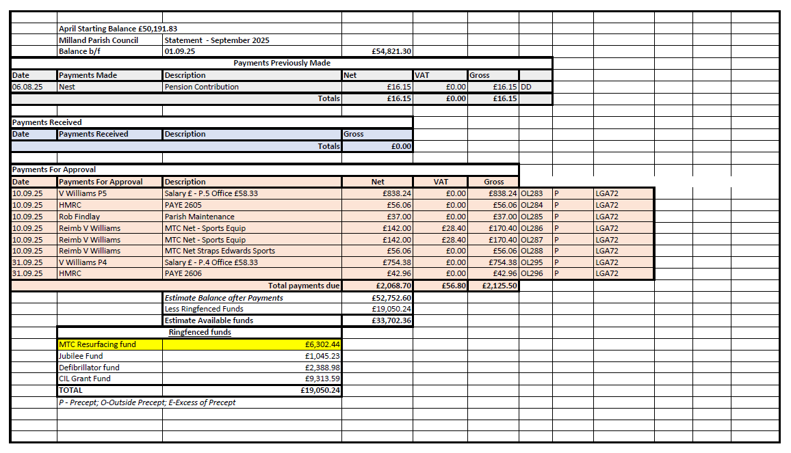
These Payments were Approved
Action: Clerk
- Community Infrastructure Levy (CIL) Funds – Speed Indicator Devices
- Following the circulation of various options of potential speed indicator devices (Full detail attached) summary below:

Manufacturer | Description | COST (exc VAT) | Additional cost  (exc VAT) | Warranty
Messagemaker Displays | Smiley Activated Message (SAM) | £2300.00 | Solar panel:  £500.00 | 5 years (parts and labour)
START SAFETY UK | Start Traffic Speed Finder Smiley Radar Sign | £3385.02 | Spare battery & fixings:  £80.71 | 1 year (parts and labour)
Pandora Technologies Ltd | Radar speed sign with additional large ‘SLOW DOWN/THANKYOU’ message and green “smiley”/red “sad” face | £2600  attached to an existing post – option (a) | Solar kit & fixings  £665.00 | 2 years (parts and labour)
- It was AGREED that Speed Indicator Devices should be considered from a portion of the CIL funds. GM to further investigate positions and full cost for installation etc. A formal decision on type of sign and installer to be made at the November meeting.
Action: GM
- Precept Meeting
- It was AGREED that the next meeting of the finance committee for drafting the 2026/27 precept would take place on the 18th October 2025.

- Review and Acceptance of Notice and Conclusion of 2024/25 Audit
- The Clerk reported that the External Audit Report and Certificate 2024/25 had been received confirming the conclusion of the Audit.
Summary of the report:
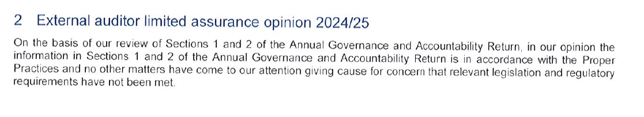
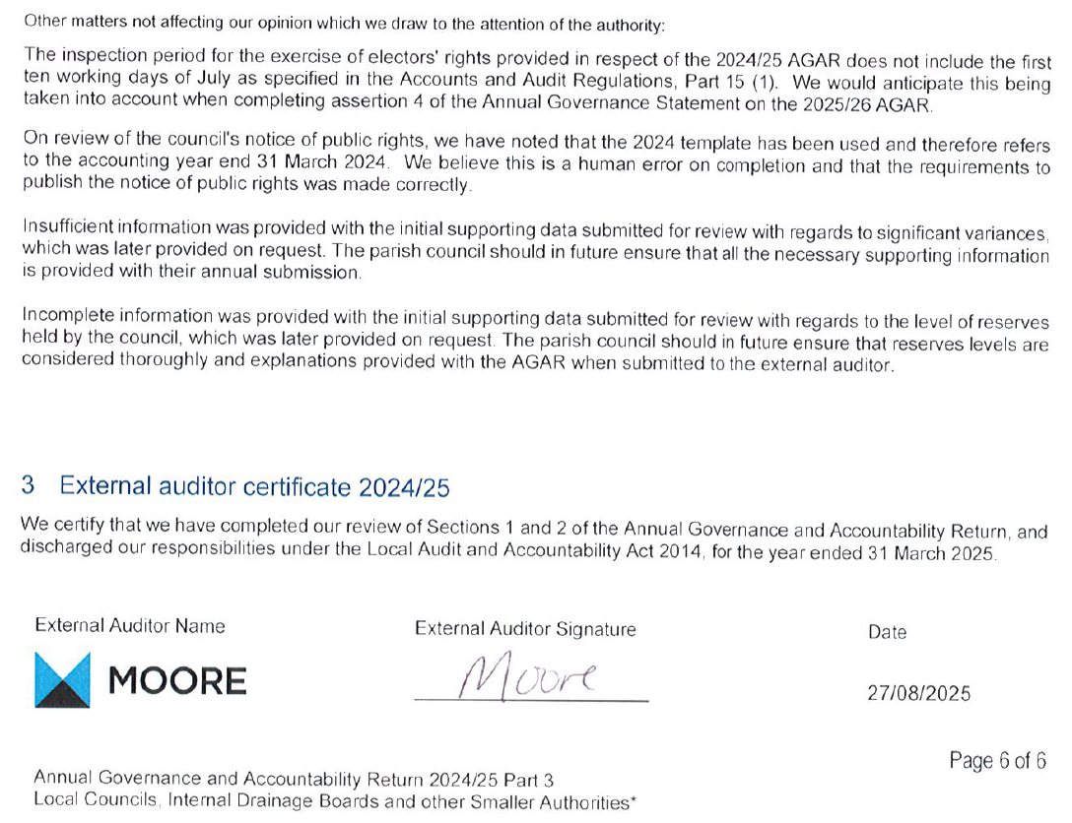
This was AGREED.

- Grant Application
- The Clerk had previously circulated an email received from Chichester District Foodbank requesting information on applying for a PC grant.
- After discussion it was AGREED that this was not Parish Specific and therefore not supported. The Clerk is to confirm whether the foodbank does cover the Parish in which case it can be revisited.
Action: Clerk
262 Parish Notices
None

263. Date of next meeting – 12 November 2025 – 6pm at Milland Memorial Hall

Chairman: Date :_________________
These Minutes are unconfirmed until signed by the Chairman.

Manufacturer | Speed Detection Device description | COST (excluding VAT) | Additional cost options  (excluding VAT) | Warranty
Messagemaker Displays  www.messagemaker.co.uk | Smiley Activated Message (SAM)  Displays the speed of an oncoming vehicle combined with either a red “sad” face for speeding or green “smiley” face for keeping within the speed limit | Cost: £2300.00  (On board battery or mains powered as standard) | Solar panel:  £500.00 (telephone conversation quote) to convert SAM to battery & solar powered | 5 years (parts and labour)
START SAFETY UK www.startsafety.uk | Start Traffic Speed Finder Smiley Radar Sign  Displays the speed of an oncoming vehicle combined with either a red “sad” face for speeding or green “smiley” face for keeping within the speed limit | Product code – 22721  (battery powered)  Cost £2493.16  Product code – 22722  (battery + solar panel)  Cost £3385.02 | Spare battery:  £58.32  Fixing:  Galvanised sign post (ht 2m/77mm diameter) £18.29  Tamper proof sign clamp £4.10 | 1 year (parts and labour)
Pandora Technologies Ltd  www.radarspeedsigns.co.uk | Radar speed sign with additional large ‘SLOW DOWN/THANKYOU’ message and green “smiley”/red “sad” face | Product code – PTSC 906  (On board battery as standard)  Cost £2600  attached to an existing post – option (a) | Solar kit (PTSC 8012:  £475.00  Fixing:  Option (b) Aluminium post – for root fixing into soft ground (ht 4m/114mm diameter) £190.00  Option (c) Aluminium post – for surface mounting to concrete (ht 3.5m/114mm diameter) £325.00 | 2 years (parts and labour)

Parish Council Meeting – Milland - September 2025
County Councillor Report

Midhurst Fire Damaged Buildings
The following is a joint statement issued by me following a meeting recently:

A meeting was held on 26th August 2025 with all the owners of the fire damaged buildings, and representatives of the South Downs National Park Authority, Historic England, Chichester District Council, Midhurst Town Council, Midhurst District Councillor and County Councillor were also present.
The meeting’s purpose was to review any progress each of the owners have been able to make and to understand what might be needed to break any deadlock, and how this might be facilitated.
The situation is extremely complex with several businesses and insurance companies involved, and the personal toll on the owners, together with the impact on other businesses in the town, were made very clear throughout the meeting.
The façade of the buildings were discussed at great length including the steps needed to decide whether they should be retained or not, and progress was made in understanding the next steps for the owners, with support, where possible, from the authorities. These steps will be pursued and further meetings will be arranged as required.
It is impossible, due to the complexities to be specific about the details of the situation, the potential outcome, or indeed any timescales at this stage. There are still so many issues to be resolved from an insurance, and a logistical perspective where each of the owners are dependent upon each other.
However, after two and a half years, this was a really important and positive step and everyone was in agreement that continuing the dialogue going forward, is hugely important to the businesses and residents of Midhurst, and for the future of the town.

There was unanimous agreement that a specialist survey was the only possible next step. I am now working towards commissioning that survey which would need to be acceptable to the authorities, and we will be exploring with the owners how this will be financed.
Public interest is high, and people and businesses are rightly impatient and anxious for resolutions to a problem that has blighted Midhurst and surrounding villages for too long. It is important however to stress that this is an incredibly complex issue, the meeting was an important first step in getting the dialogue going again, but it is one step of many that will be needed, and people’s expectations will need to be managed accordingly.

West Sussex Joint Local Health and Wellbeing Strategy 2025-2030
New strategy to improve West Sussex residents’ health and wellbeing
A new five-year strategy has been published which is the county’s overarching plan to improve the health and wellbeing of residents and communities across West Sussex and reduce health inequalities.
Developed by the West Sussex Health and Wellbeing Board and wider partners, the plan also includes feedback following a public consultation on the draft strategy held earlier this year.
The strategy presents the Board’s vision of ‘Improving Lives Together in West Sussex.’ It focuses on five priority areas, with three principles which are central to its delivery.
The five priority areas are:
- Food and nutrition
- School readiness
- Transitioning to adulthood – children and young people’s mental health and wellbeing
- Tobacco control
- Health and wellbeing in temporary accommodation

I have attached the communications toolkit for you to use with Parish Communications.
Fire service offers free electric blanket testing
The following is important and useful public information from the fire service:

West Sussex Fire & Rescue Service is running a series of electric blanket testing sessions to help residents stay safe this winter.

Faulty electric blankets are a common cause of fire in the home. Last year more than a third (37%) of the blankets tested by the service were defective and posed a serious risk of starting a fire.

Regular testing is recommended for blankets over two years old to ensure they are still safe to use. Blankets over ten years old should be replaced.

The sessions will take place on the dates below by appointment only. For venues with events running over two days, appointments will only become available on the second day after the first day has been fully booked.

You can book an appointment to have your blanket tested by calling 0345 872 9719.
- Tuesday 30 September and Wednesday 1 October (9.30am – 4.30pm) – Bognor Fire Station, West Meads Drive, Bognor Regis PO21 5TB
- Thursday 2 October (10am – 4pm) – Horsham Library, Lower Tanbridge Way, Horsham RH12 1PJ
- Tuesday 7 and Wednesday 8 October (9.30am – 4.30pm) – Durrington Community Centre, 2 Romany Road, Worthing BN13 3FJ
- Thursday 9 October (10am – 4pm) – Shoreham Library, St Mary’s Road, Shoreham-by-Sea BN43 5ZA
- Tuesday 14 and Wednesday 15 October (9.30am – 4.30pm) – Haywards Heath Fire Station, Mill Green Road, Haywards Heath RH16 1XQ
- Thursday 16 October (10am – 4pm) – Crawley Library, Southgate Avenue, Crawley RH10 6HG

The sessions will also be attended by nurses from the Prevention Assessment Team and the Sussex Fraud Team who will be on hand to offer advice and support.
West Sussex Fire & Rescue Service’s Safe and Well Manager Samantha Barber said: “We are really pleased to be offering free electric blanket testing again this year.
“Last year we tested 286 blankets and 105 were deemed unsafe to use as they failed to meet safety standards, which posed a great fire risk.

“We would encourage residents to come and have their blankets tested to ensure they have peace of mind that their blanket is still safe to use. Please book an appointment to meet our friendly team.

” If your blanket is found to be faulty, a limited number of replacement blankets will be available thanks to our partnership with SGN. These will be given free of charge to vulnerable residents who receive certain benefits, while stocks last.”
Further advice on keeping safe and warm at home can be found at https://www.westsussex.gov.uk/fire-emergencies-and-crime/west-sussex-fire-and-rescue-service/home-fire-safety/electrical-and-heating-appliance-safety-advice/

Update from Chichester District Council September 2025 for Fernhurst Ward

LGR update
The Local Government Reorganisation survey closed on 13 August, and CDC are now in the process of reviewing the responses.
These insights will form an important part of the business case that they will submit to the Government by 26 September, along with the other councils in West Sussex. Each council will also send a letter outlining its preferences.
Before this, we will have the opportunity to discuss the proposals at a full council meeting, so please let us know your views.
Once submitted, we expect the Government to launch a formal consultation process in November. This will be another important opportunity for people to share their views.
A final decision is anticipated in March 2026.

Local Plan
In August, the council adopted the Local Plan for Chichester District. This marks a significant milestone in shaping the future of the area, setting out a comprehensive vision for the area’s economy; transport and housing needs; environmental and historic protection; community health and wellbeing; and cultural development. The council has worked hard to prepare and now adopt the new Local Plan, having faced a number of significant challenges, particularly around roads, wastewater, and water neutrality.

Parks
Chichester’s Parklands, Priory Park, Whyke Oval and Oaklands Park are now open following major upgrades. Each play area has been designed with a unique theme inspired by its location.
Priory Park features a castle-themed play area, reflecting the site's rich Norman history. Parklands play area, located on Sherborne Road, has been transformed with a coastal theme, including a dolphin play panel and an 'under the sea' tunnel.

Graffiti
If you see any graffiti, please do report it to the District Council Waste and Recycling Team at wasteandrecycling@chichester.gov.uk or 01243 534 619

Contacting your District Councillors
Brett can be contacted on email bburkhart@chichester.gov.uk or telephone 07876594168
Ellie can be contacted on email enewbery@chichester.gov.uk or telephone 01428 656 941 or at the Fernhurst Hub on Thursday 15 September 11-12.30

